**1. Use the method of elimination to find the solution to the given system.**

|  |  |
| --- | --- |
|  |  |

**2. Find the solution to each of the following system of equations.**

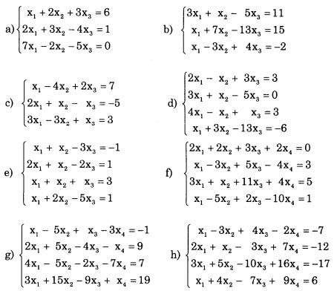

3. Solve the homogeneous system of linear equations

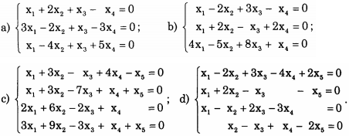

e.



f.

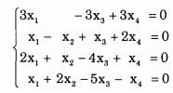

4. Find x, y so that the matrix



1. is row-echelon matrix
2. is reduced row-echelon matrix

5. The director of a trust fund has $100.000 to invest. The rules of the trust state that both a certificate of deposit (CD) and a long – term bond must be used. The director’s goal is to have the trust yield $7800 on its investments for the year. The CD chosen returns 5% per annum and the bond 9%. Determine the amount x to invest in the CD and the amount y to invest in the bond.

6. An inheritance of $24000 is to be divided among three trusts, with the second trust receiving twice as much as the first trust. The three trust pay interest annually at the rates of 9%, 10% and 6%, respectively and return a total in interest of $2210 at the end of the first year. How much was invested in each trust?